Library management system

Usecase

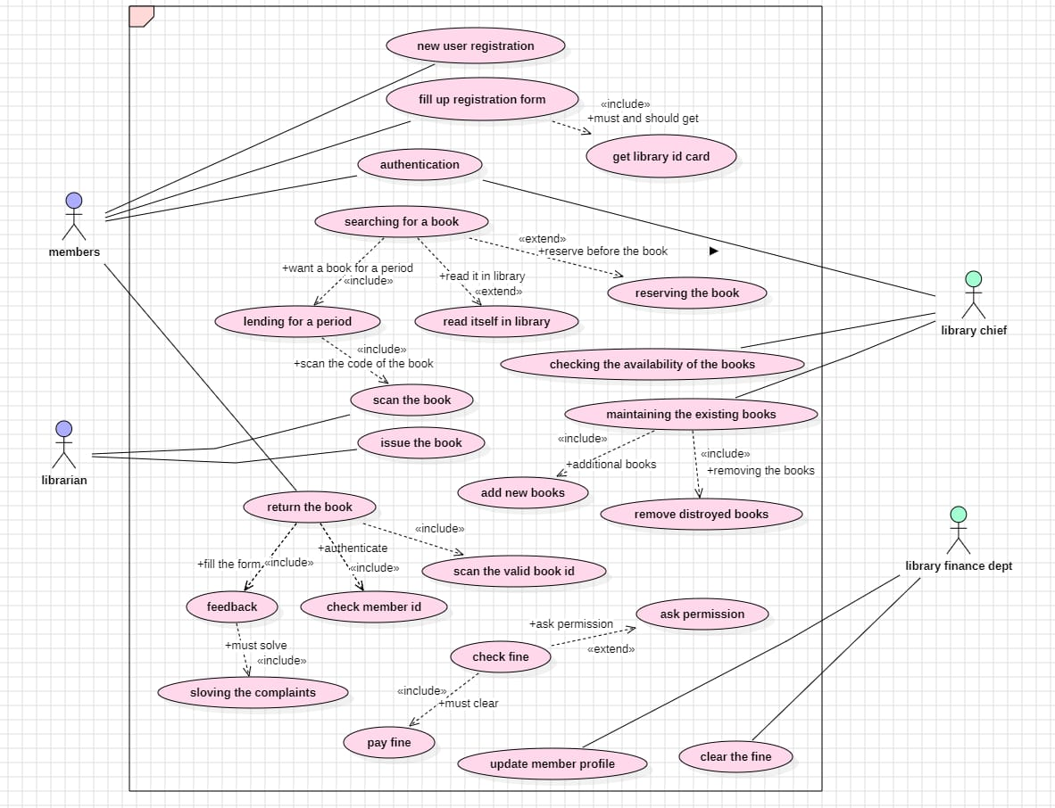

Activity

Class

Sequence

State chart

